EMCH 290-001-HW#6 Due at 11:59 on Friday, December 2, 2022
Points Possible: 100 (Each 25)
6.47 As shown in Fig. P6.47, an insulated box is initially divided into halves by a frictionless, thermally conducting piston. On one side of the piston is 1.0 m³ of air at 400 K, 3 bar. On the other side is 1.0 m³ of air at 400 K, 1.5 bar. The piston is released and equilibrium is attained, with the piston experiencing no change of state. Employing the ideal gas model for the air, determine
a. the final temperature of the air, in K.
b. the final pressure of the air, in bar.
c. the amount of entropy produced, in kJ/K.
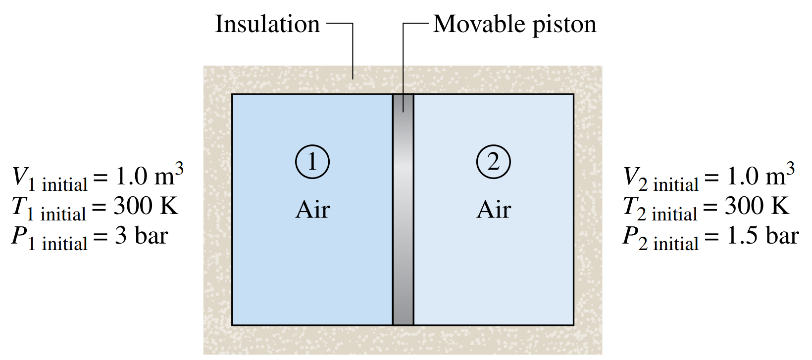

6.50 A closed, rigid tank contains 5 kg of air initially at 300 K, 1 bar. As illustrated in Fig. P6.50, the tank is in contact with a thermal reservoir at 600 K and heat transfer occurs at the boundary where the temperature is 600 K. A stirring rod transfers 600 kJ of energy to the air. The final temperature is 600 K. The air can be modeled as an ideal gas with c_{υ} = 0.733 kJ/kg ⋅ K and kinetic and potential energy effects are negligible. Determine the amount of entropy transferred into the air and the amount of entropy produced, each in kJ/K.
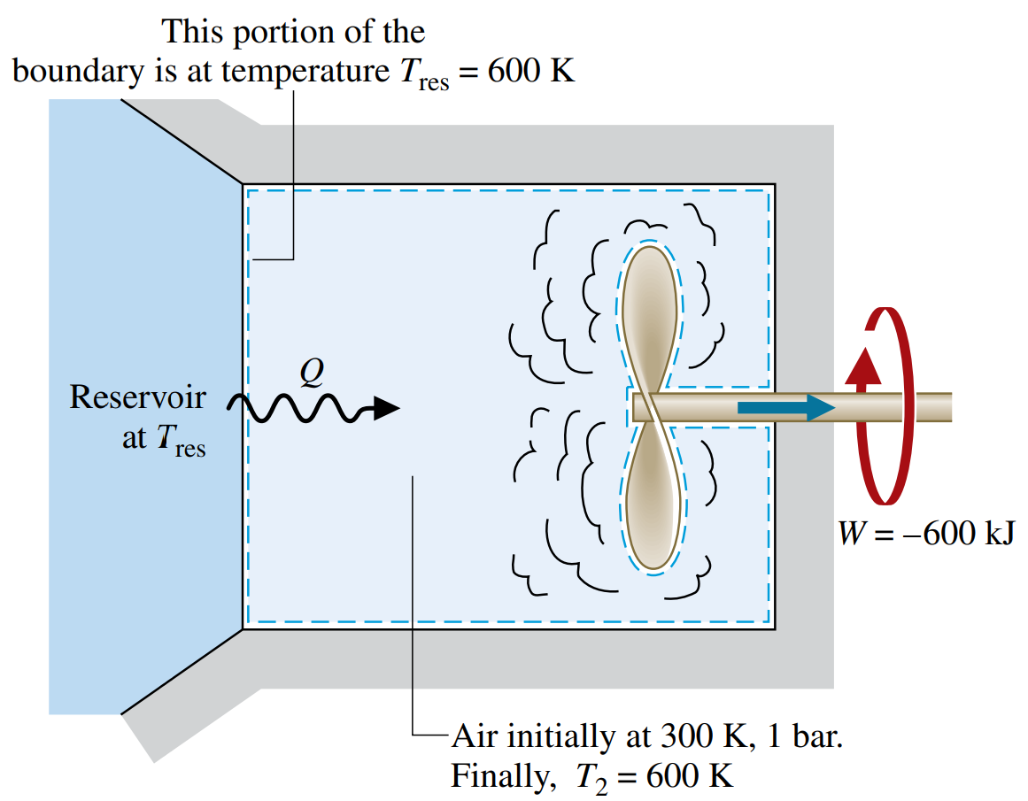

6.53 The heat pump cycle shown in Fig. P6.53 operates at steady state and provides energy by heat transfer at a rate of 15 kW to maintain a dwelling at 22°C when the outside temperature is −22°C. The manufacturer claims that the power input required for this operating condition is 3.2 kW. Applying energy and entropy rate balances evaluate this claim.
Write a brief statement detailing why or why not.
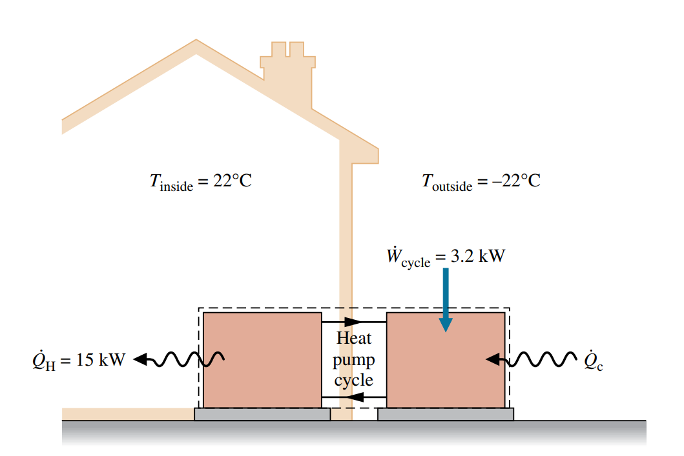

6.74 Figure P6.74 shows an air compressor and regenerative heat exchanger in a gas turbine system operating at steady state. Air flows from the compressor through the regenerator, and a separate stream of air passes though the regenerator in counterflow. Operating data are provided on the figure. Stray heat transfer to the surroundings and kinetic and potential energy effects can be neglected. The compressor power input is 6700 kW. Determine the mass flow rate of air entering the compressor, in kg/s, the temperature of the air exiting the regenerator at state 5, in K, and the rates of entropy production in the compressor and regenerator, in kW/K.
